**R Basics using RStudio**

[](https://skills.network/?utm_medium=Exinfluencer&utm_source=Exinfluencer&utm_content=000026UJ&utm_term=10006555&utm_id=NA-SkillsNetwork-Channel-SkillsNetworkCoursesIBMDA0321ENSkillsNetwork21426264-2022-01-01)

**Hands on Lab:R Basics using RStudio**

**Estimated time needed:** 15 minutes

**Learning Objectives**

* Get familiar with RStudio
* Write your first R code snippet in RStudio

# RStudio main UI

In this lab, you will be introduced to RStudio, the most popular and powerful IDE for developing R projects.

The main UI of RStudio is shown here:

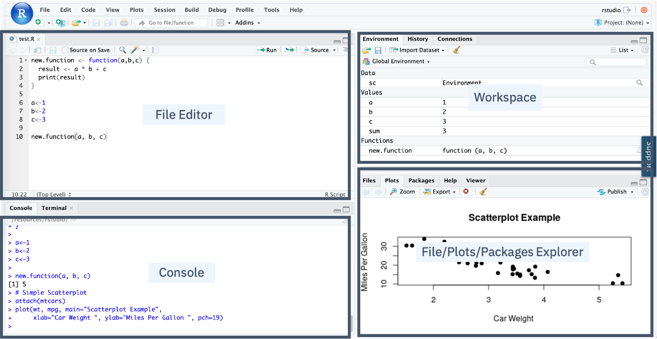

* In the Console panel, you can quickly try some R commands and see the results immediately.
* In the File Editor panel, you can write your R code or other text files with the help of syntax highlighting and auto completion.
* In the Workspace panel, you can review and manage the created objects.
* In the File/Plots/Package Explorer panel, you can manage your files and other assets, such as plots or packages.

**Write the first Hello World code snippet in the Console**

Let us write your first **Hello World** in RStudio Console.

* Find the blinking cursor in the Console panel, type an incomplete prin or print and pause a little bit for RStudio to show a pop-up suggestion list:

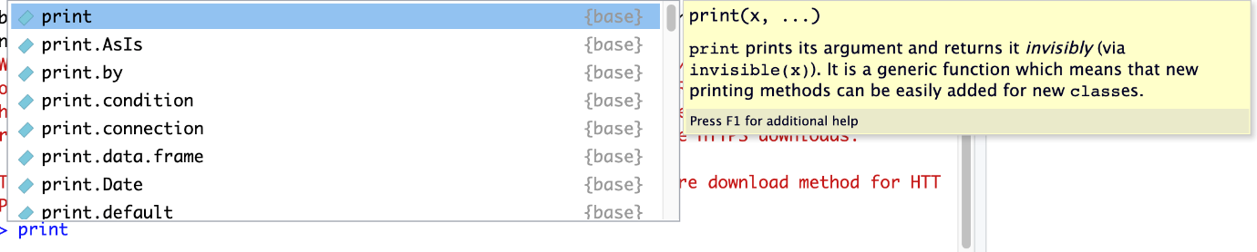

The auto-complete feature of RStudio can help avoid the need for memorizing the code details and reducing keystrokes by just selecting from a suggestion list.

* Select the print function and add a character input Hello World!, then press the Enter key:

1. 1
2. print("Hello World!")

Copied!

You should see Hello World! printed on the console.

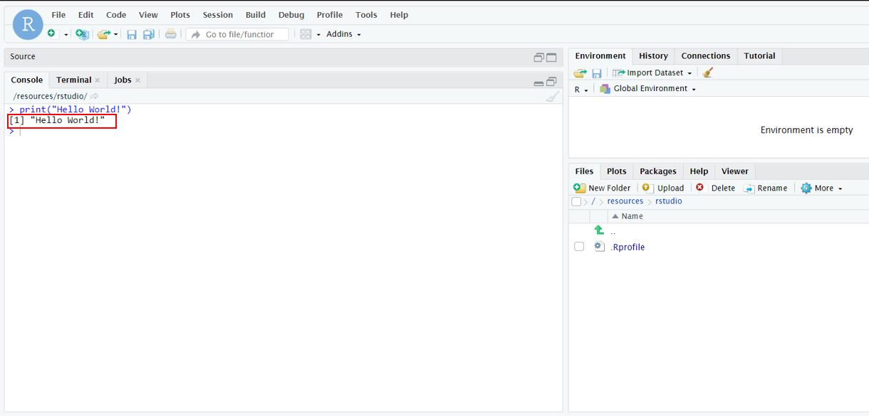

That’s it, you have written your first Hello World code snippet in RStudio.

For practice, you can play with the console by typing anything you have learned so far, such as creating variables and doing basic math operations.

If you want to clear the console, you can press Ctrl or Control + L key combination.

**Review R objects in the Environment panel**

Now let’s try the Environment panel to review the R objects we created in the console.

* Type and run the following three lines of code in the console:

1. 1
2. x<-1

Copied!

1. 1
2. y<-2

Copied!

1. 1
2. z<-x+y

Copied!

You should see three variables x, y, z with assigned values in the Environment panel.  
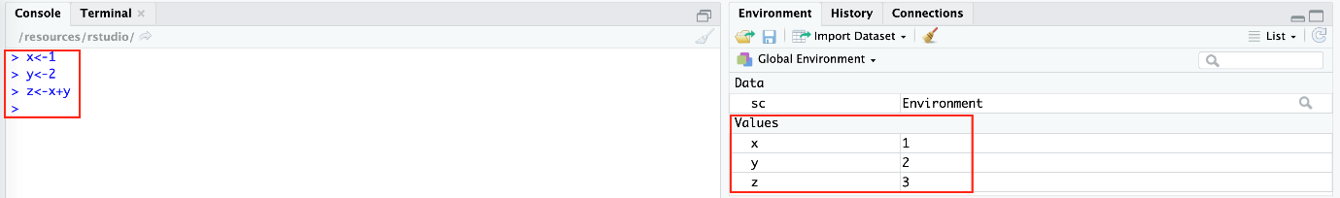

* To clean the workspace, you can click the Broom icon as shown below:

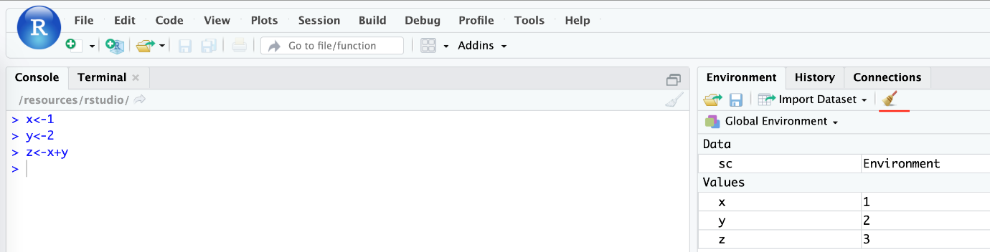

**Create your first R script file**

By now, you have written some simple R code in the console interactively. Next, create an R script file with multiple lines of code and run them in batch mode.

* First, from the menu click File > New File > R Script.

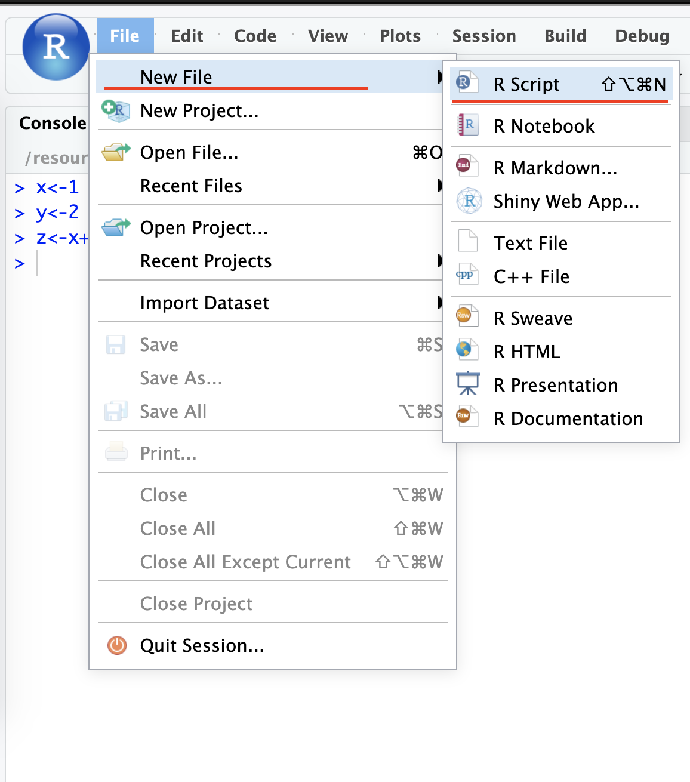

* Then click File > Save, and name the file something like first_script. After the script file is saved, you can see an empty file called first_script.R file created in your working directory.

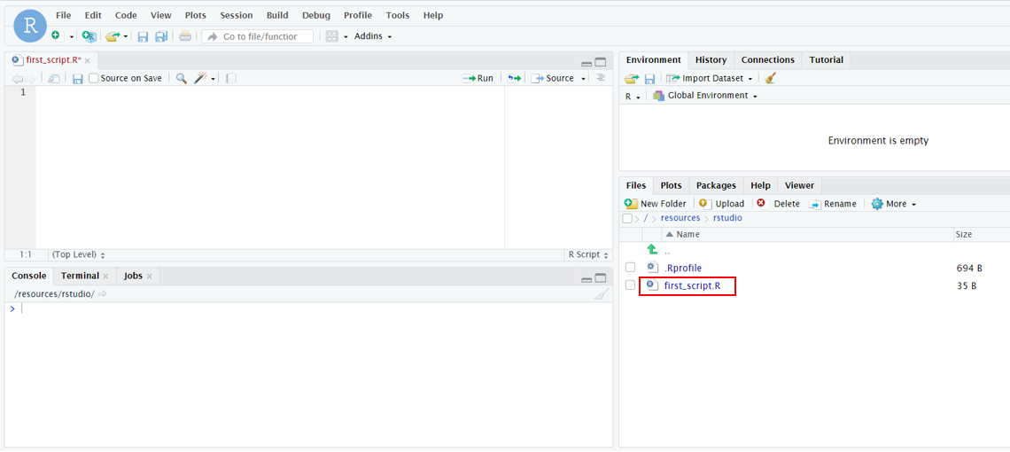

* Next, click first_script.R file to add the following code snippet:

1. 1
2. 2
3. 3
4. 4
5. x <- 3
6. y <- 4
7. z <- x + y
8. print(z)

Copied!

You need to make sure the last line of the file is a new empty line.

So after copying the code snippet above, press the Enter key to start a new line in the script file.

Now, you can run the code in the script file, there are two running modes:

* The first mode is called Run the current line or selection. You can click and drag your mouse or use Shift + Up/Down keys to select all lines and then click the following Run icon to run them:

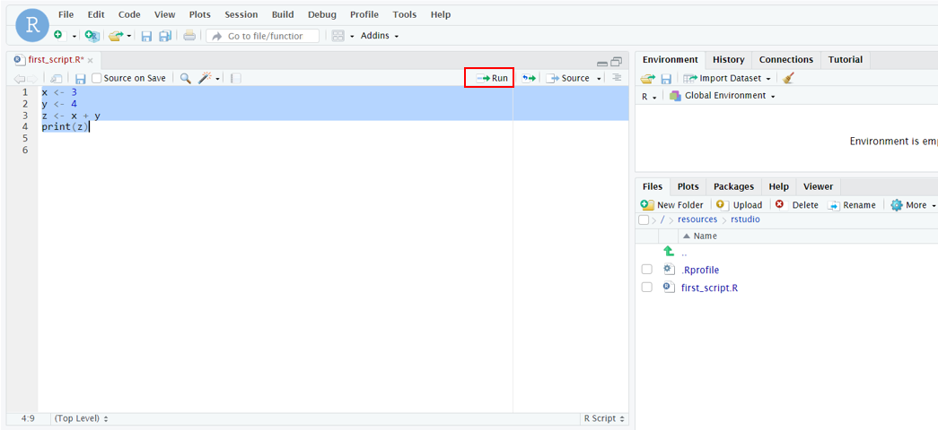

* The second mode is called Source where it runs all lines of code in the file by clicking the following Source icon:

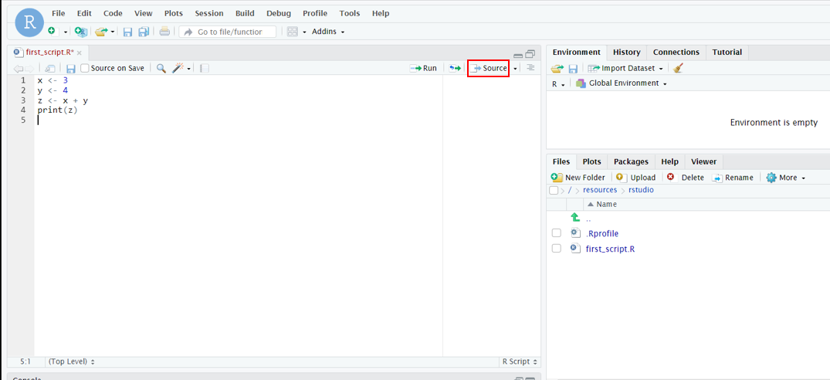

You should see the results in the console:

1. 1
2. 2
3. source('/resources/rstudio/first_script.R')
4. [1] 7

Copied!

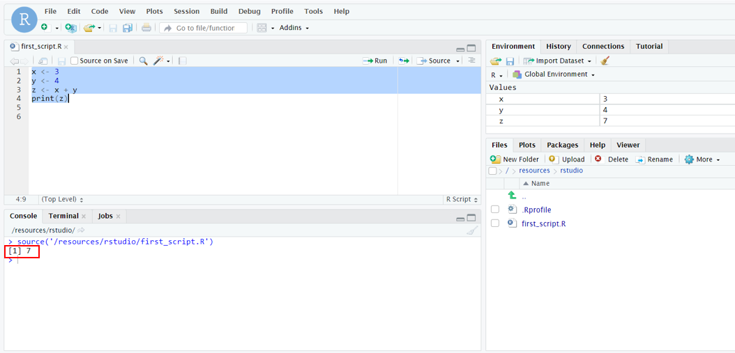

That’s it about creating and running the R script file!

**Exercise: Practice Tasks**

**Task 1:** Create a new R script

* Assign two variables where x = 10 and y = 20.
* Save the file as **Subtract.R**.

Click here for solution

1. 1
2. 2
3. x <- 10
4. y <- 20

Copied!

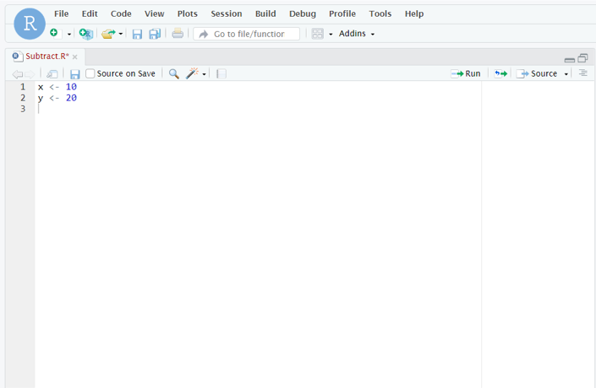

**Task 2:** Subtract x from y. Store in variable result and print the output.

Click here for solution

1. 1
2. 2
3. 3
4. 4
5. x <- 10
6. y <- 20
7. result <- y - x
8. print(result)

Copied!

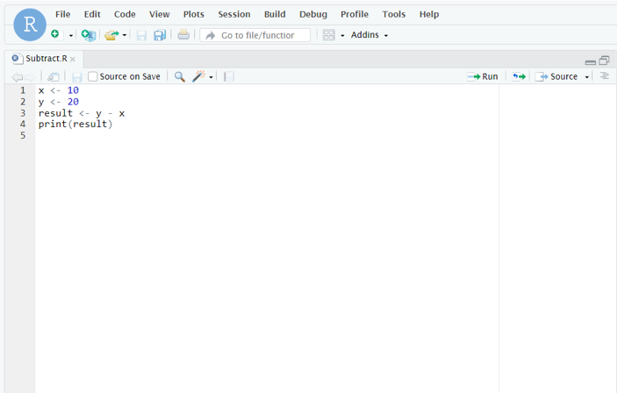

# Summary

In this lab, you have been introduced to RStudio. You have practiced how to write and run R code in both the console and in R script files. You used the Environment panel to review the R objects in your workspace.

### Thank you for completing this lab!

## Author(s)

[Pratiksha Verma](https://www.linkedin.com/in/pratiksha-verma-6487561b1/?utm_medium=Exinfluencer&utm_source=Exinfluencer&utm_content=000026UJ&utm_term=10006555&utm_id=NA-SkillsNetwork-Channel-SkillsNetworkCoursesIBMDeveloperSkillsNetworkDS0105ENSkillsNetwork984-2022-01-01)

## Changelog

| **Date** | **Version** | **Changed by** | **Change Description** |
| --- | --- | --- | --- |
| 2022-12-20 | 1.1 | Steve Hord | QA pass |
| 24-08-2022 | 1.0 | Pratiksha | Initial version created |

### IBM Corporation 2021. All rights reserved.